Define hypothesis statements.

You’ve spent a lot of time learning about the users you're designing for, and how empathy and user research can improve your understanding of users' needs. As a reminder, here's where you're at in the design process:

* **Empathizing** with users allows you to consider the product experience from the users’ perspective. By connecting with people directly, like through interviews, you can discover and understand users' likes, dislikes, and pain points.
* Then, sort through research you collected about users to **define** the problem they're facing. Creating a problem statement helps you clearly define the user pain points that your future designs can address.

Now, you can begin coming up with solutions that address those problems! You’re ready to create hypothesis statements. A **hypothesis statement** is an educated guess about what you think the solution to a design problem might be. You know the challenges users are facing, so it’s time to consider how your designs can alleviate their pain points.

Hypothesis statements don’t have a single standard formula to follow, but there are two common methods you can try using to write one.

First, you can use the **if / then format** to come up with a hypothesis statement. Here are examples of if/then hypothesis statements applied to the users of the dog walker app:

* **If** Arnold downloads the dog walker app, **then** they can utilize the “simplified” mode setting to view only the basic app functions.
* **If** Tobias signs up for the dog walker app, **then** they will quickly and easily pick a walker that fits their schedule.

Second, you can use the **we believe format** to come up with a hypothesis statement. Here are examples of we believe hypothesis statements applied to the dog walker app:

* **We believe that** a simplified mode of the dog walker app **for** Arnold **will** allow them to hire dog walkers efficiently.
* **We believe that** easy access to available dog walkers **for** Tobias **will** increase the amount of walks they choose for their pets.

If / then statements focus directly on the needs of users. On the other hand, we believe statements take the perspective of your team into account, while remaining empathetic to the needs of users.

You might encounter situations where you have multiple hypothesis statements for one problem statement. That’s okay! There will always be multiple solutions for the problems that users are facing. Your job as a UX designer is to use your creativity and problem-solving skills to decide which solutions work best for the unique users you’re designing for.

Hypothesis statements help you narrow down your research insights into goals for your product, so you can stay focused on the wants and needs of your users.

Activity Exemplar: Build a problem statement and hypothesis statement for the CoffeeHouse project

Here is a completed exemplar along with an explanation of how the exemplar fulfills the expectations for the activity outlined in the previous reading.



This is an exemplar created using the CoffeeHouse scenario we have been following in this course.

Here's a link to that scenario for this course item, click the link below and select “Use Template.”

Link to scenario: [CoffeeHouse Business Scenario](https://docs.google.com/document/d/1Ln-ycFqSyOeAKFhVAlKuBVjG6ER6GluJ2JwNwZVwvfU/template/preview" \t "_blank).

**OR**

If you don’t have a Google account, you can download the scenario directly from the attachment below.

**[Google UX Design Certificate - CoffeeHouse Business Scenario](https://d3c33hcgiwev3.cloudfront.net/oa8d1w19RYyvHdcNfXWMFg_9b7df45ee8364b8692b9364cdcde19f1_Google-UX-Design-Certificate---CoffeeHouse-Business-Scenario.docx?Expires=1682208000&Signature=QQ5w9wt5bkERNAI22k16wR~LG9m8Ep8IUBw1riAXE~Xdd8ftj0tNdl9EG3XdPxMpf3j06yd9-zBkGhW5C8wlIpgGA-38rlj4xe-qRpuAc6R4BcpuWYmNLPE6Eh-603C5C57QInb7jFO71mlJYs4RkJfkXE6lc8LEwoVLOWh6-ec_&Key-Pair-Id=APKAJLTNE6QMUY6HBC5A" \t "_blank)**

[DOCX File](https://d3c33hcgiwev3.cloudfront.net/oa8d1w19RYyvHdcNfXWMFg_9b7df45ee8364b8692b9364cdcde19f1_Google-UX-Design-Certificate---CoffeeHouse-Business-Scenario.docx?Expires=1682208000&Signature=QQ5w9wt5bkERNAI22k16wR~LG9m8Ep8IUBw1riAXE~Xdd8ftj0tNdl9EG3XdPxMpf3j06yd9-zBkGhW5C8wlIpgGA-38rlj4xe-qRpuAc6R4BcpuWYmNLPE6Eh-603C5C57QInb7jFO71mlJYs4RkJfkXE6lc8LEwoVLOWh6-ec_&Key-Pair-Id=APKAJLTNE6QMUY6HBC5A" \t "_blank)

Here is an example problem statement for one of the personas we created using this scenario:

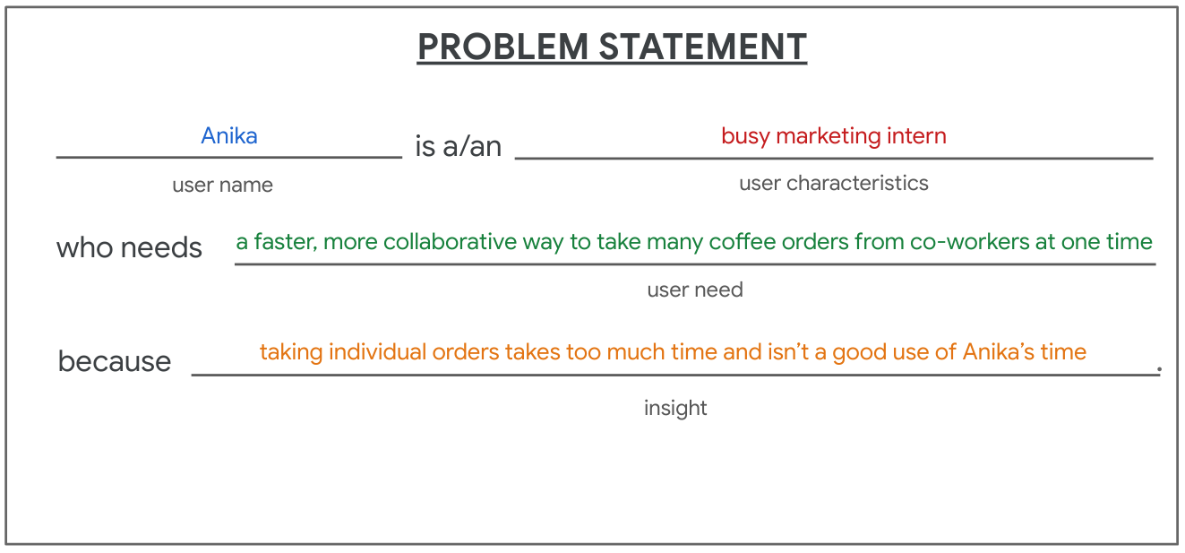Anika is a/an bust marketing intern who needs a faster, more collaborative way to take many coffee order from co-workers at one time because taking individual orders takes too much time and isn't a good use of Anika's time.

Here is an example of a hypothesis statement that matches with the problem statement.

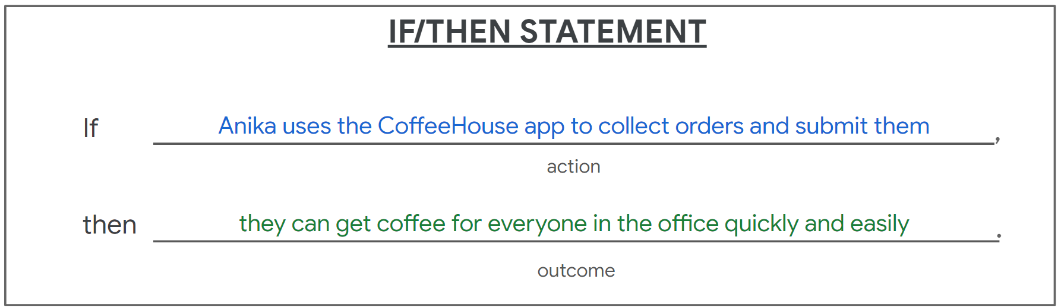Anika hypothesis statement: If Anika uses the CoffeeHouse app to collect orders and submit them, then they can get coffee for everyone in the office quickly and easily.

And here is another example problem statement for the second persona we created for the CoffeeHouse scenario:

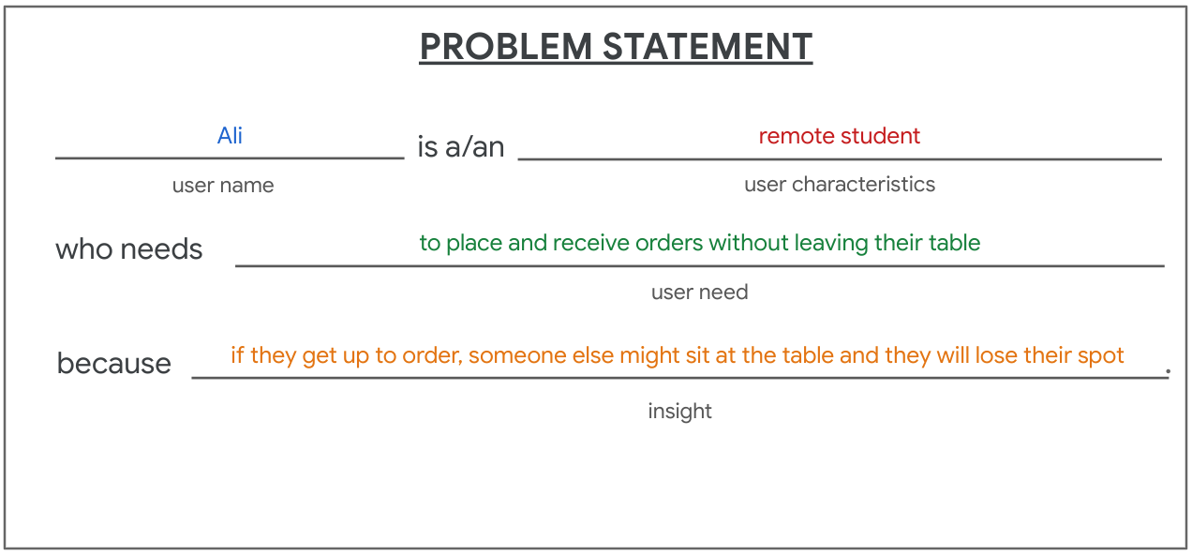Ali is a/an remote student who needs to place and receive order without leaving their table because if they get up to order, someone else might sit at the table and they will lose their spot.

Here is a hypothesis statement that corresponds with Ali’s problem statement.

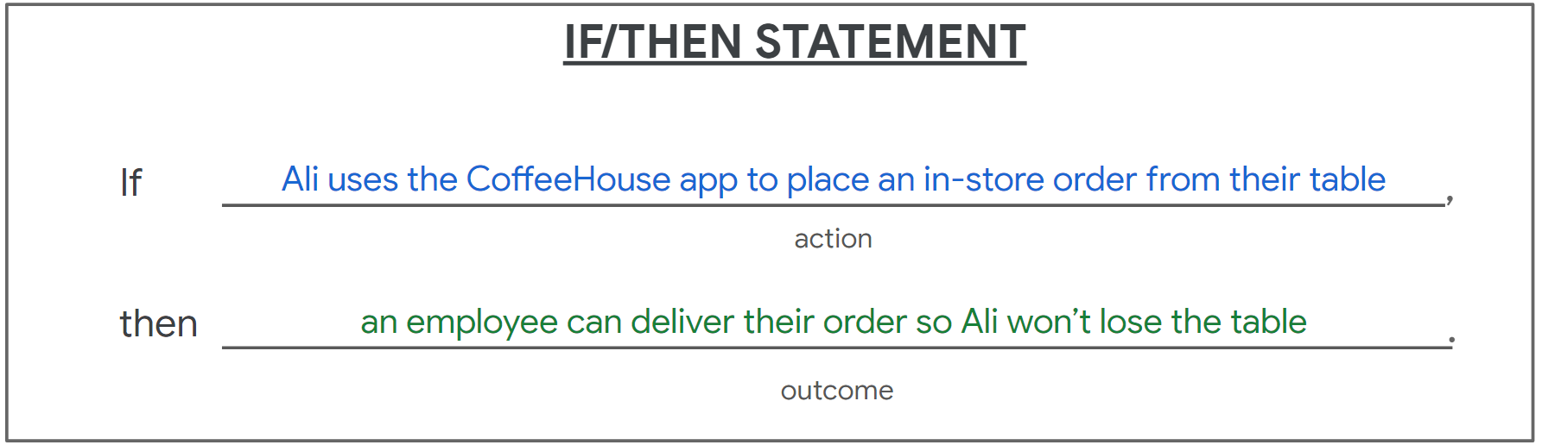Ali hypothesis statement: If Ali uses the CoffeeHouse app to place an in-store order from their table, then an employee can deliver their order so Ali won't lose the table.



In this exemplar, each problem statement:

1. Starts with the name of the user.
2. Adds a short description of the user’s characteristics.
3. Clearly describes the user’s need.
4. Explains why the user has that need.

With these parts clearly defined, the problem statement is:

* Human-centered and focused on the needs of a specific type of user.
* Broad enough for creative freedom.
* Narrow enough to be solved by a practical design solution.

The matching hypothesis statements express a clear design goal and the criteria for success:

* By stating a specific action they tell us what our solution should enable the user to do.
* By stating the desired outcome they give a specific accomplishment. This helps determine whether the solution was successful in meeting the user’s need.

Now compare the exemplar above to your completed deliverable. Assess what you’ve done using each of the criteria used here to evaluate the exemplar.

Have you constructed a problem statement that is:

* Human-centered and focused on the needs of a specific persona?
* Broad enough for creative freedom?
* Narrow enough to be solved by a practical design solution?

From your problem statement were you able to formulate a corresponding hypothesis statement that:

* States a specific action and tells us what your solution should enable the user to do?
* States the desired outcome that determines whether your solution was successful in meeting the user’s need?

If you’re able to answer ‘Yes’ to each of these questions, nice job! If there are questions you were unable to answer ‘Yes’ to, then these are areas where you can improve your problem and hypothesis statements. Go back and try re-writing your statements with these criteria in mind!